
CGD Hooking Up Portal
(External User Request)
[User Manual]

Contents
1 Introduction 2
2 User side Request 2
3 User Side 2
3.1 User Registration 2
3.2 User Navigation Points 1
3.3 Raise New Request 1
3.4 My Request 4
3.5 Pending for Action 4
3.6 Admin (GA-User Mappings) 4

Introduction

SAMANVAY is a digital platform developed by GAIL to manage and streamline the process of CGD (City Gas Distribution) connectivity requests, GA-ZO mappings, user authorization, and related approvals.
The system has two interfaces:
- Admin Side: For administrators to manage requests, mappings, registrations, and reports.
- User Side: For CGD entities to register, raise requests, and track progress.

User side Request
User will first login from following screen:

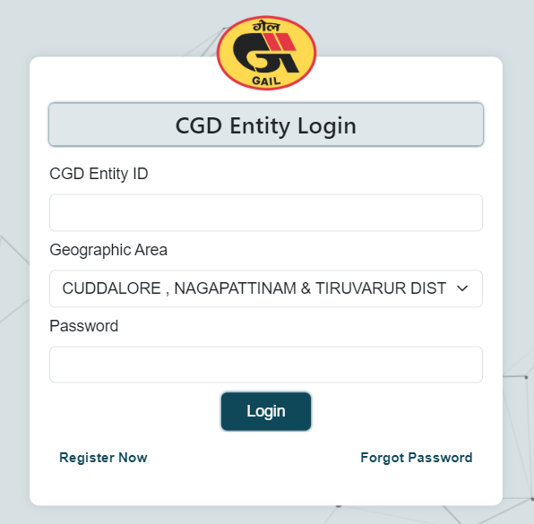

User Side

3.1 User Registration
Entities must register before using the system.
Registration Form Fields:
- Entity Details

  - Entity Name *
  - Corporate Identification No (CIN)
  - PAN *
  - GSTIN Number *
  - Address Line 1 *
  - Address Line 2
  - State * (dropdown)
  - City *
  - PIN *

- Geographic Area Details

  - Geographic Area * (dropdown)
  - GA ID (auto-populated)
  - Zonal Office (auto-populated)

- Contact Details

  - User Name *
  - Designation *
  - Mobile Number * (verify via OTP)
  - Email * (verify via OTP)

Declaration:
The entity must declare PNGRB authorization of at least one GA and confirm information accuracy.
On Submission:
- A unique Entity ID and Password are generated.
- These credentials are used for login.
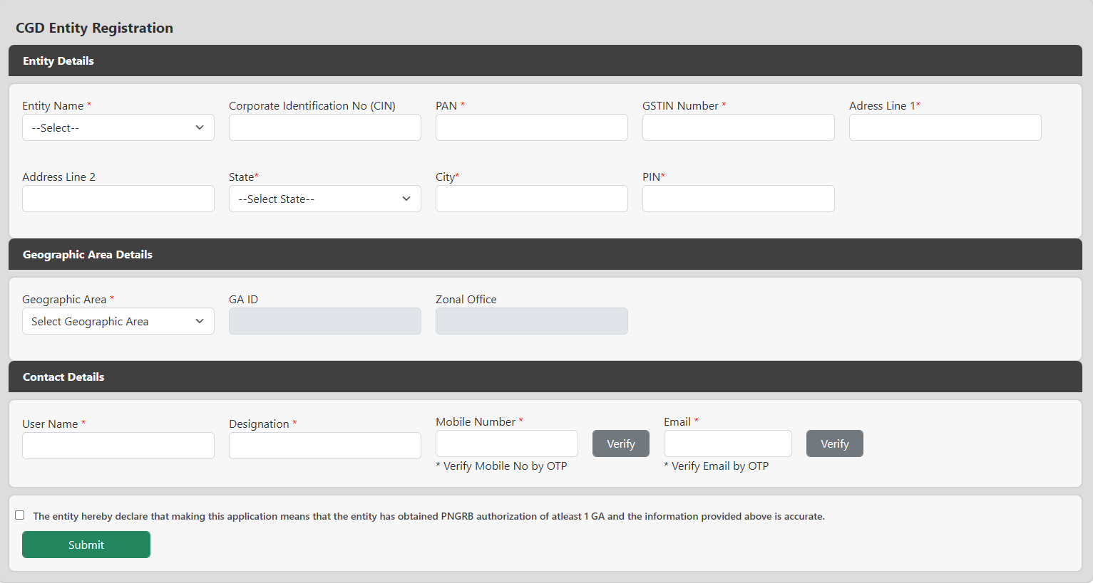

3.2 User Navigation Points

After login, the user can access the following modules:
- Raise New Request
- My Request
- Pending for Action
- Admin (GA-User Mappings)

3.3 Raise New Request
This is a 4-stage request submission process:
- Request Form
- F8 Form
- Upload Land Details
- Review & Submit
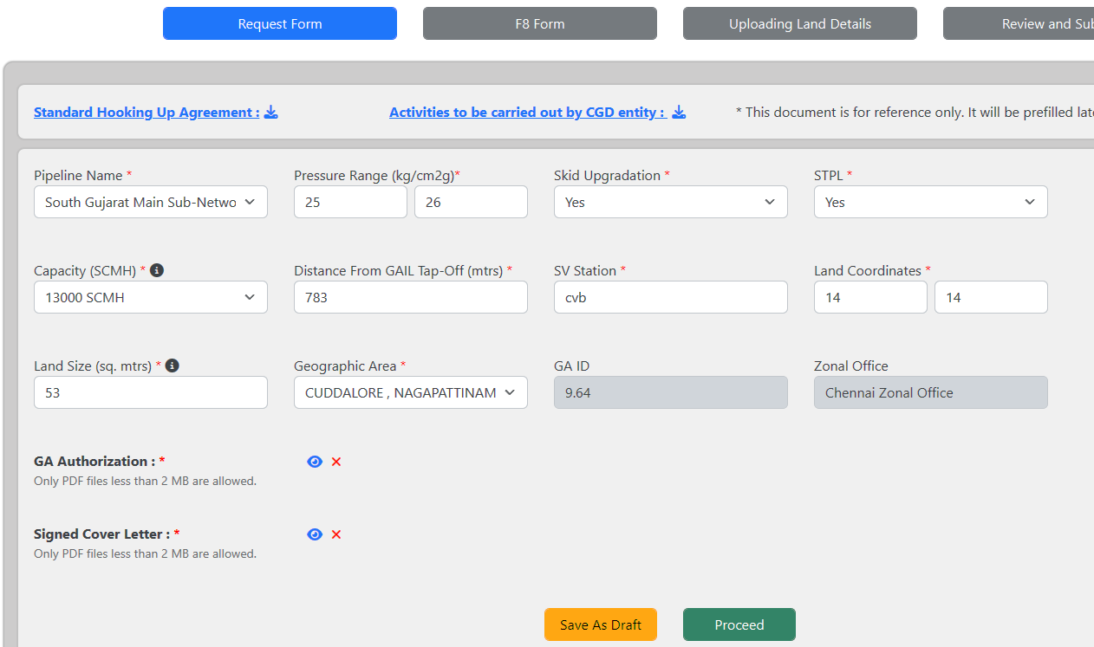
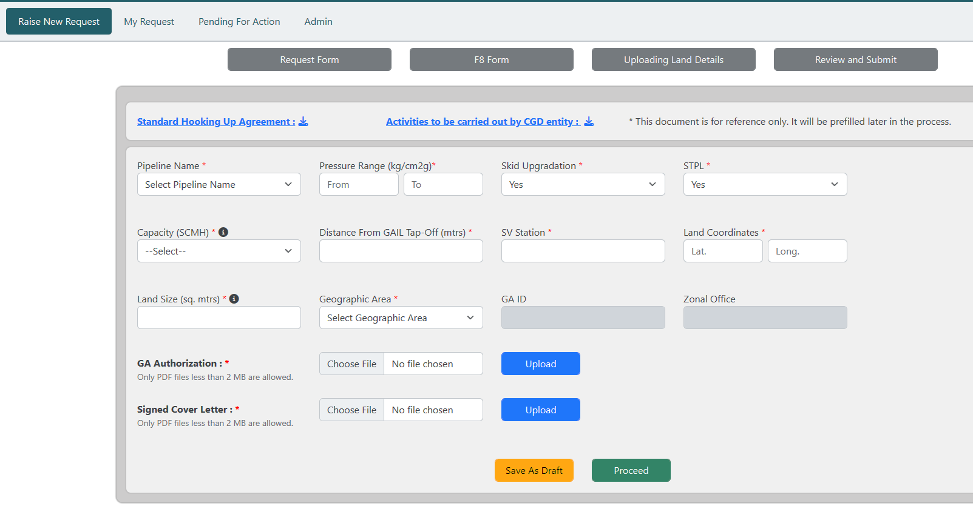

2) F8 form
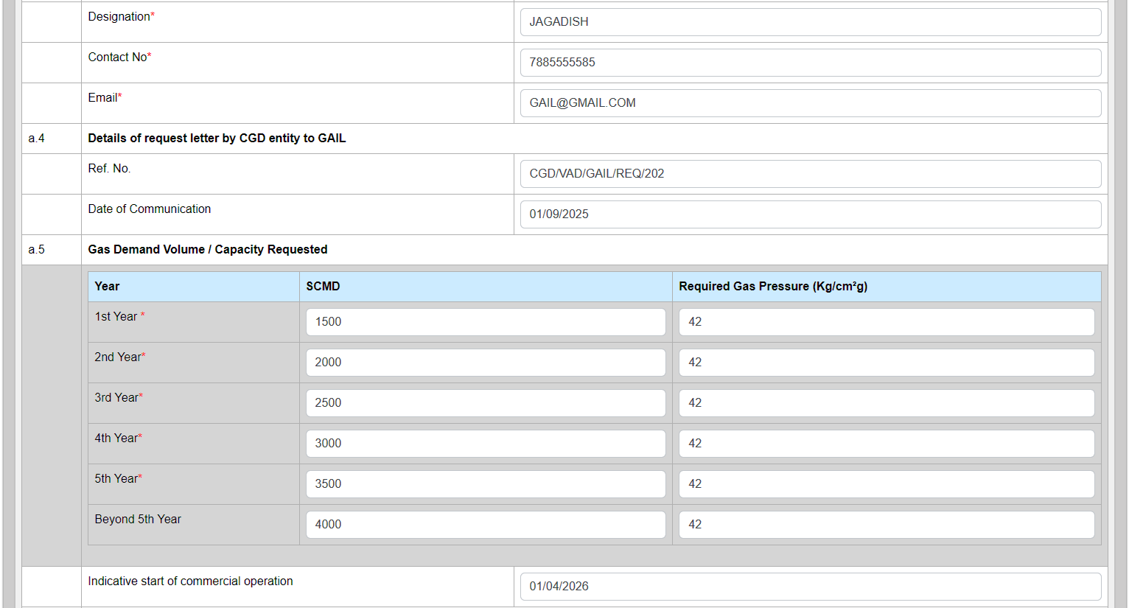
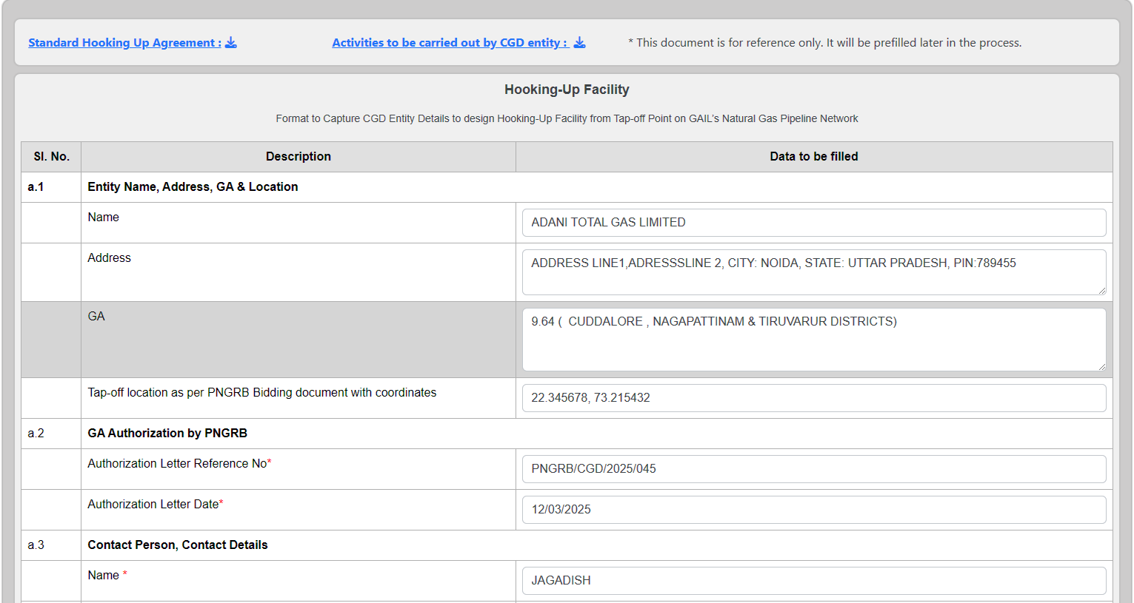
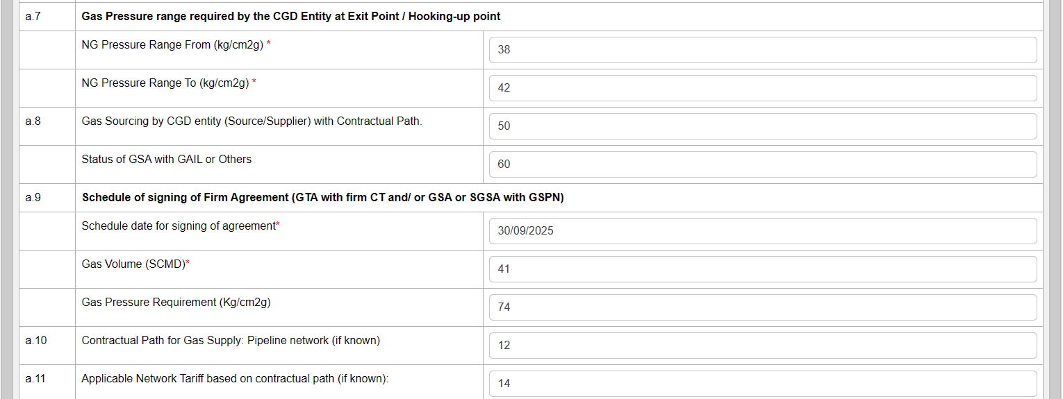
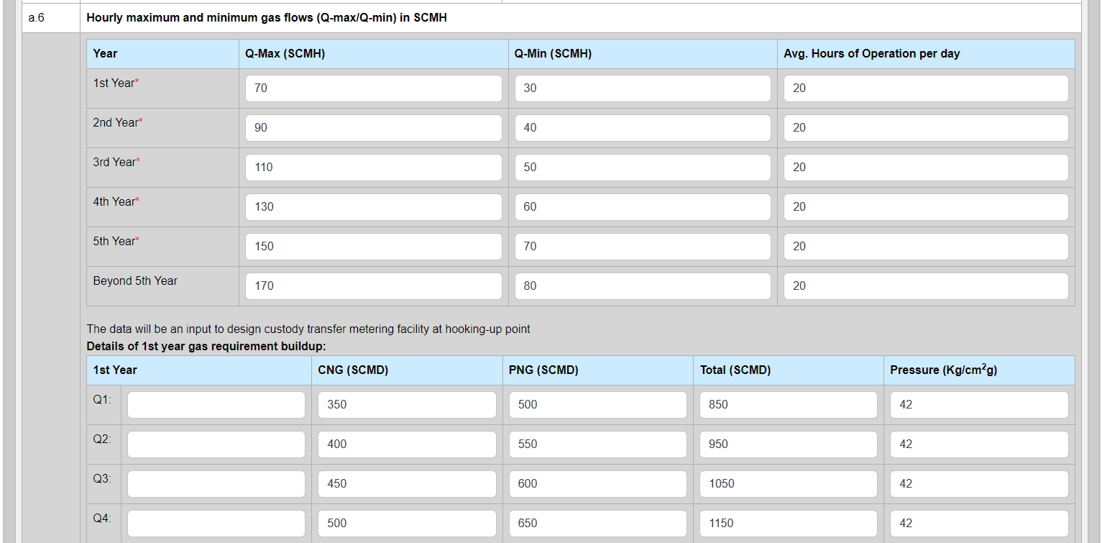
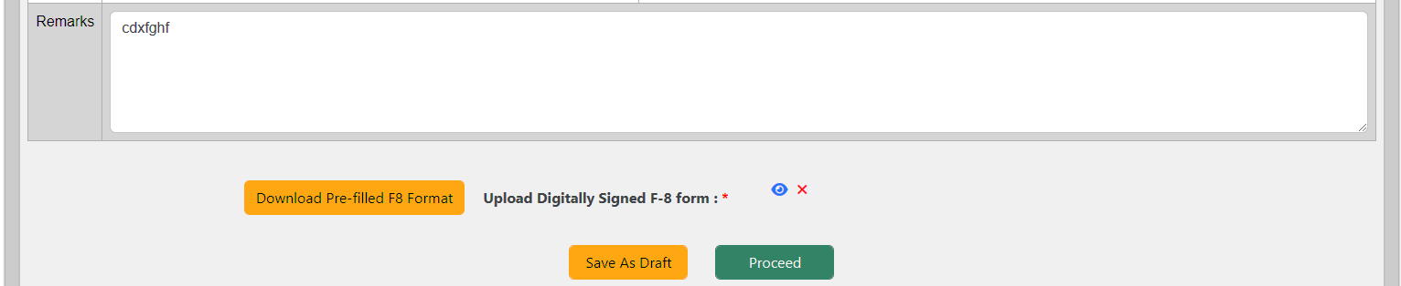
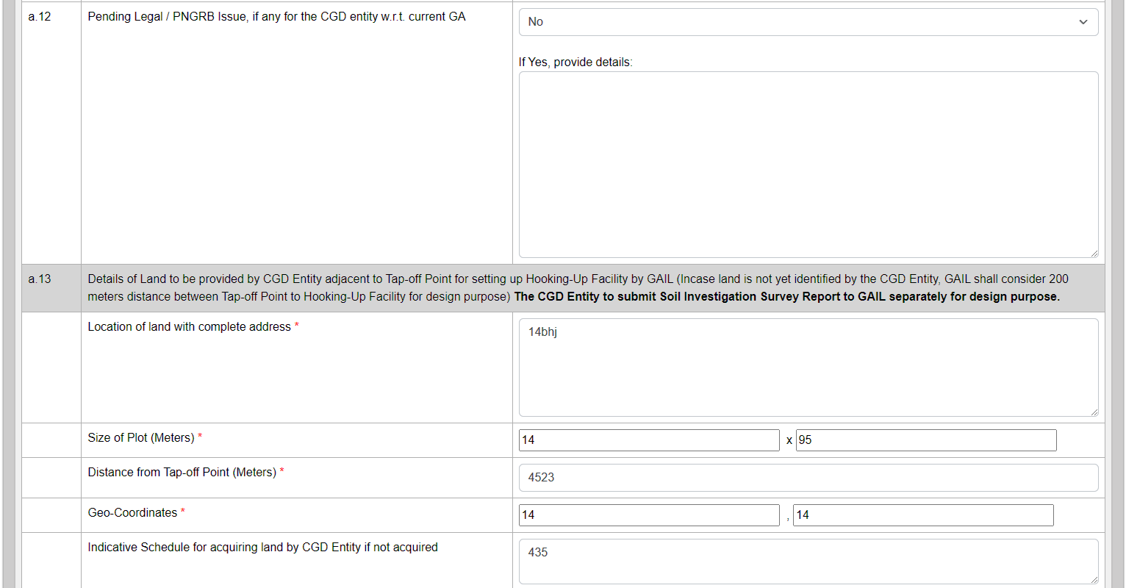
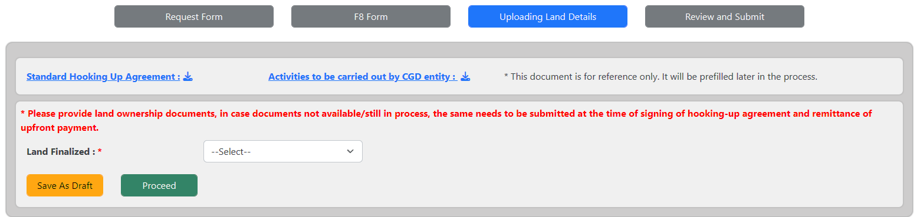
3) Uploading Land Details:
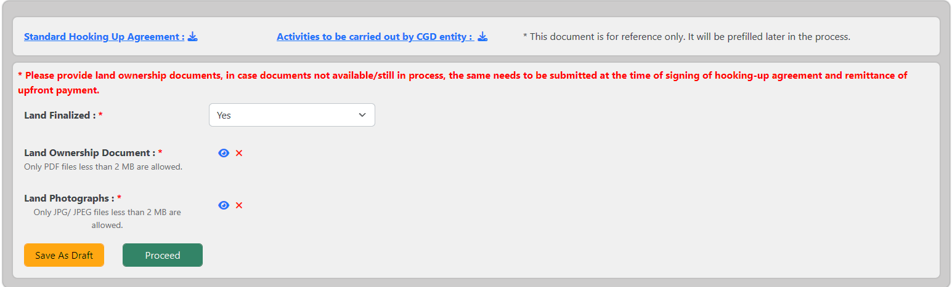
4) Review and submit

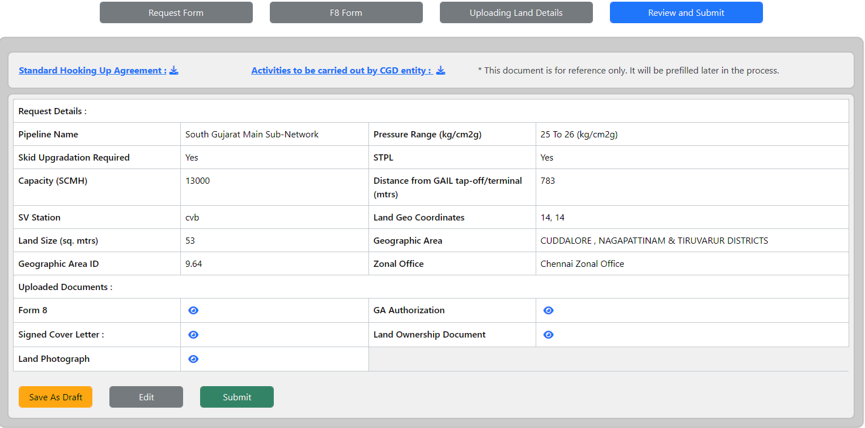

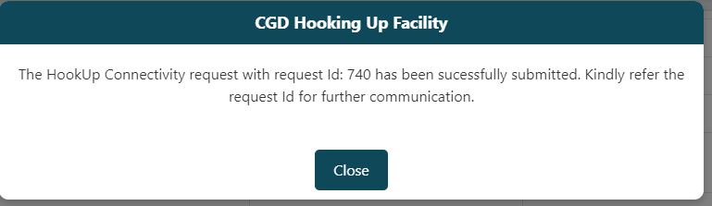

3.4 My Request
Displays all submitted requests by the entity.
Filters:
- From Date
- To Date
- Status
Request Table:

- Sl. No.
- Request ID
- Entity Name
- Geographic Area
- Zonal Office
- Submitted On
- Present Status
- Progress (with bar & hover details)
- View

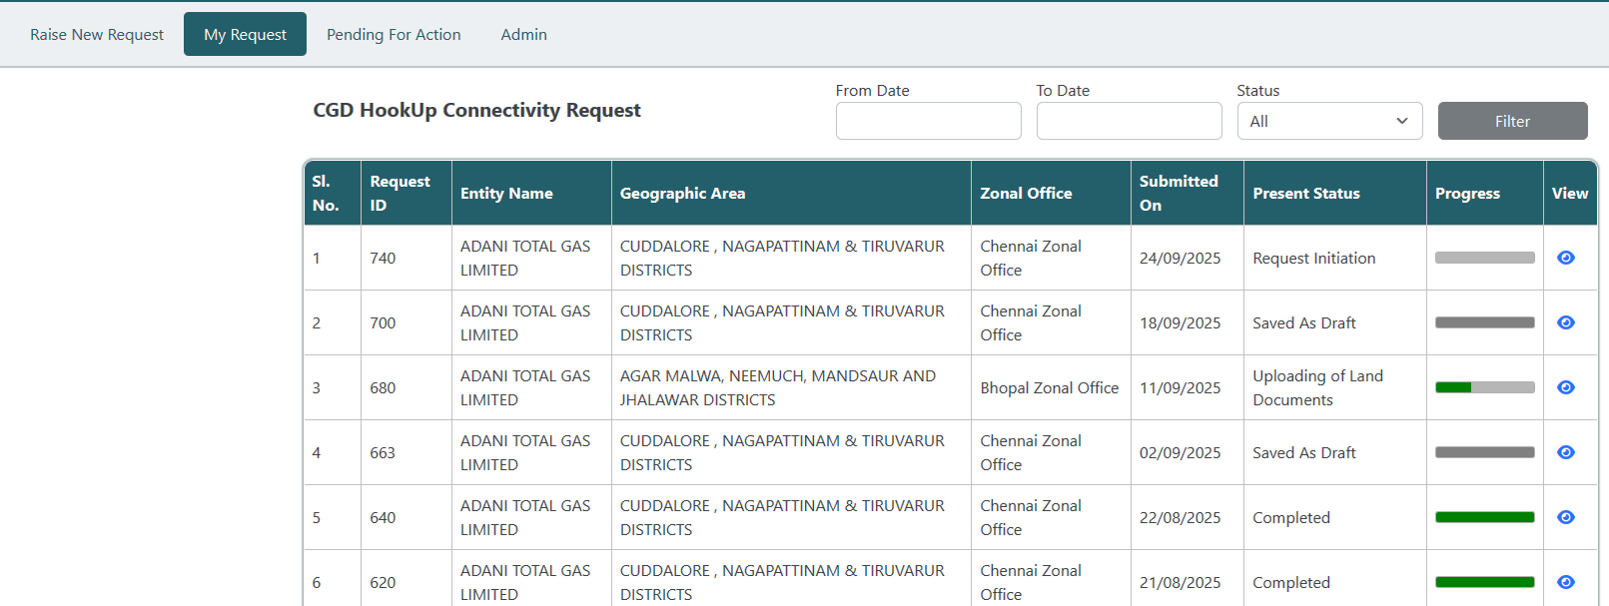
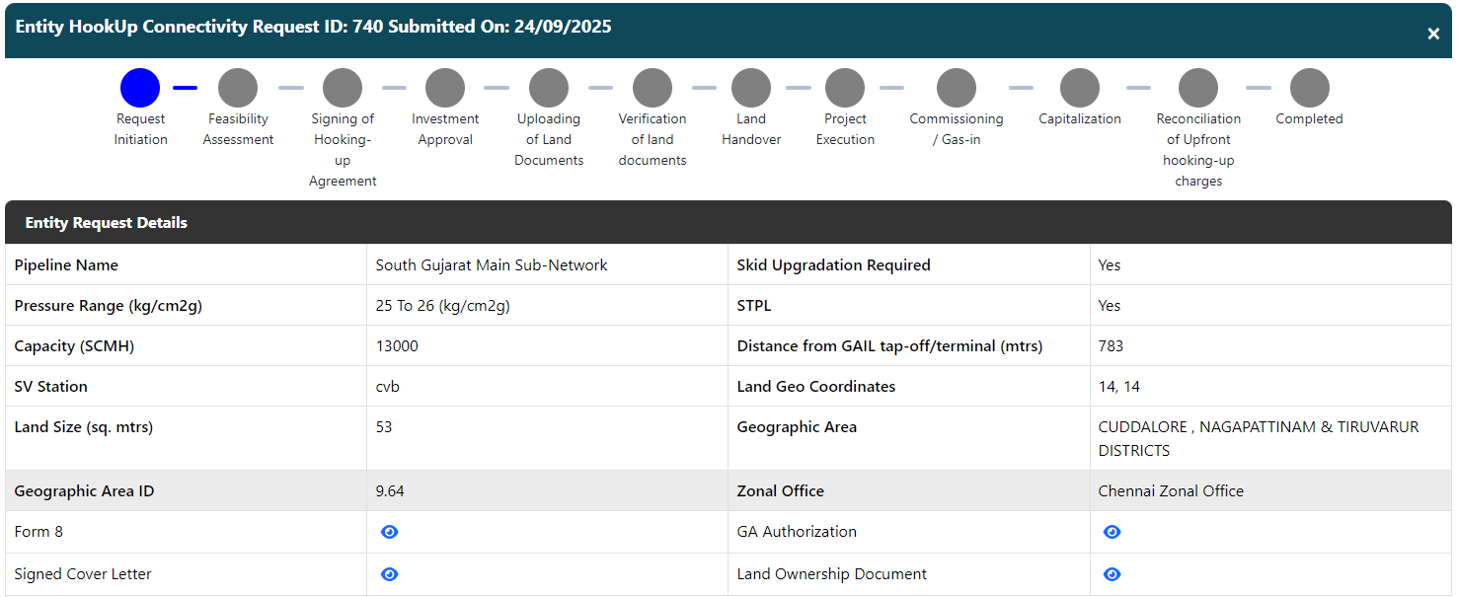
Zonal officer will see this pending request for processing as shown below:
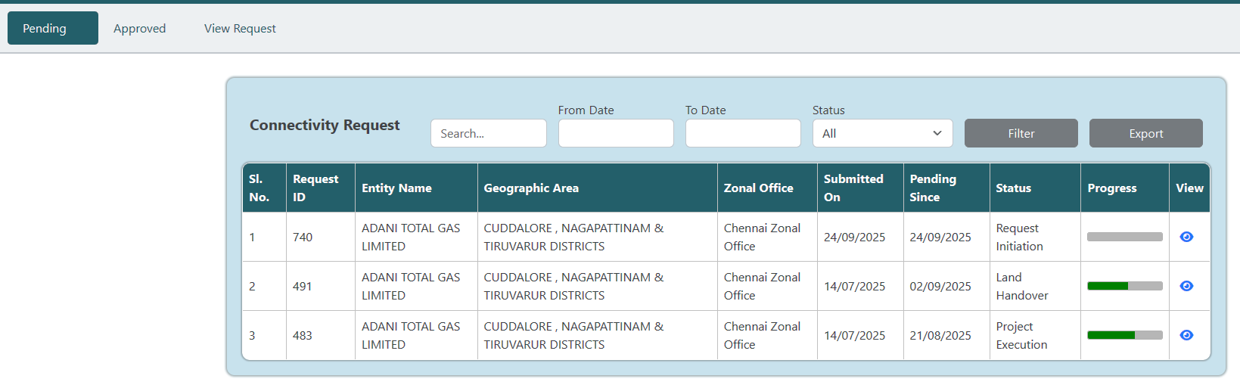

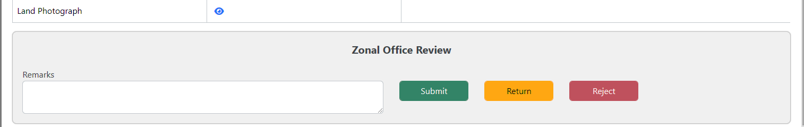

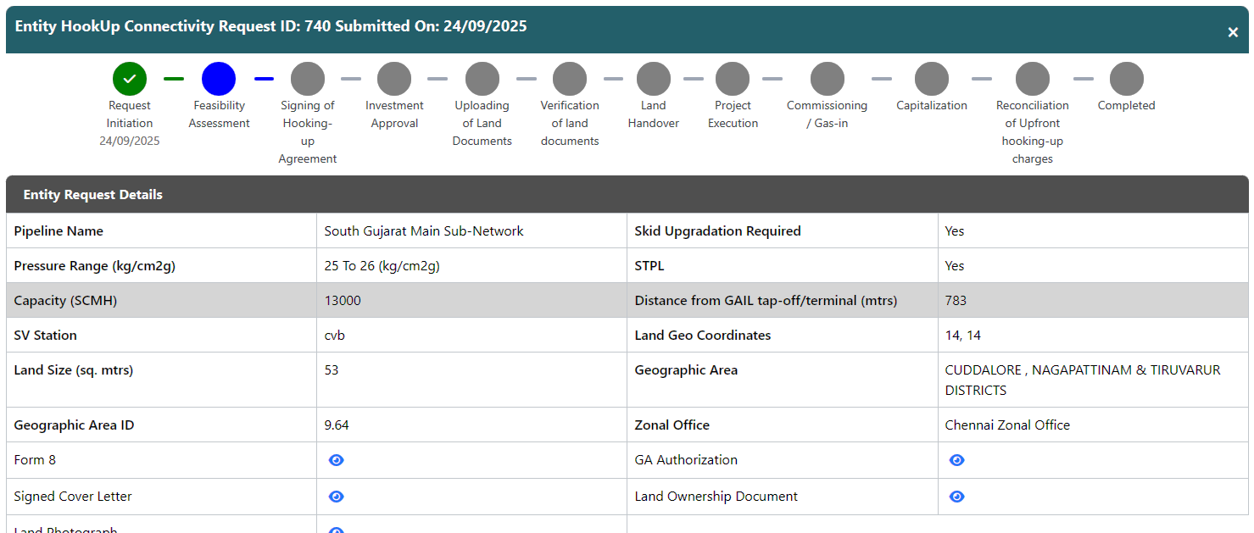

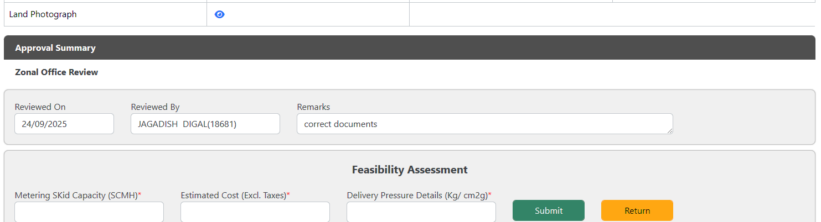

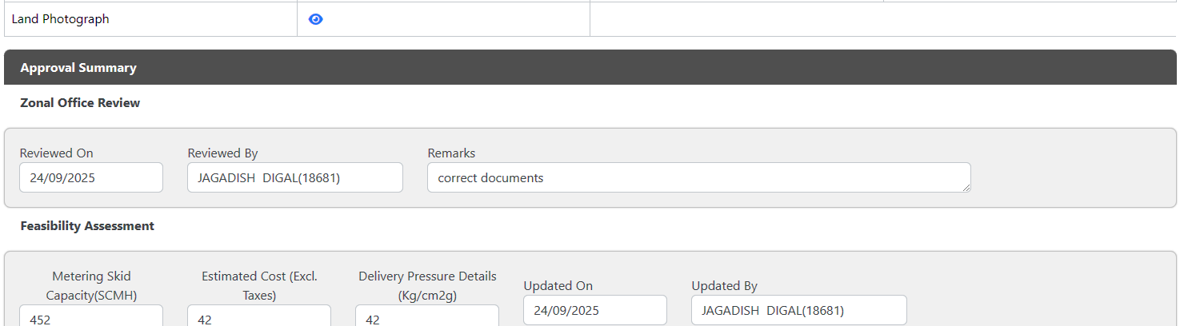
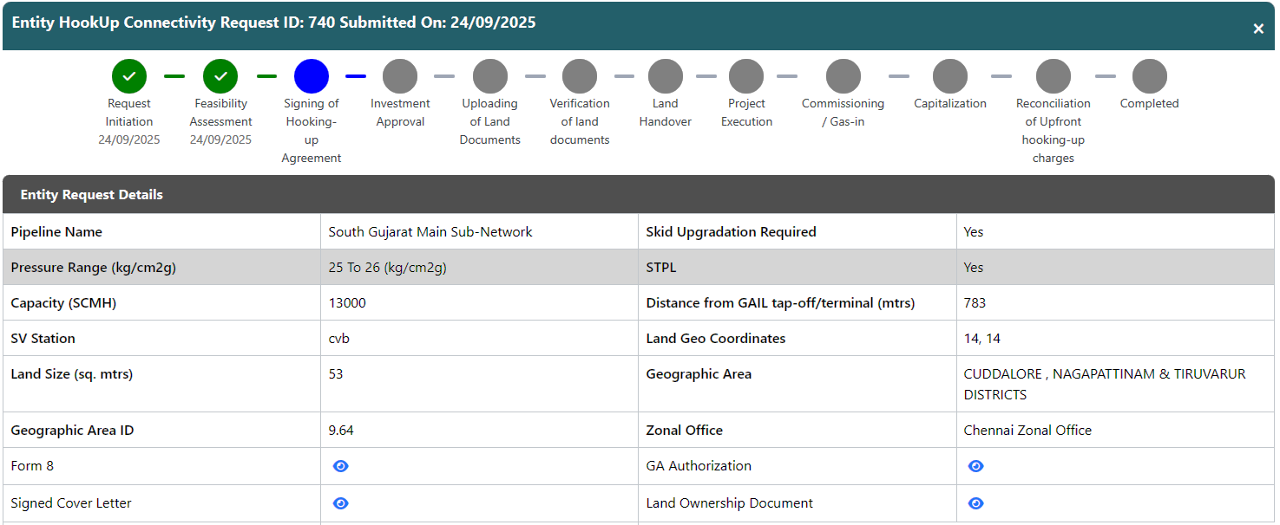

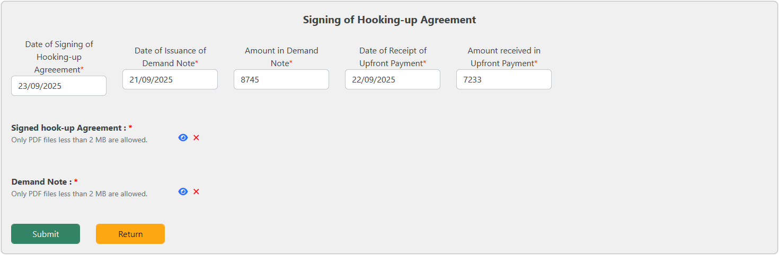

And so on goes on till all the stages are covered back and forth.

3.5 Pending for Action

Displays requests pending user input/action.
Filters:
- From Date
- To Date
- Status
Table Columns:

- Sl. No.
- Request ID
- Entity Name
- Geographic Area
- Zonal Office
- Submitted On
- Present Status
- Progress
- View

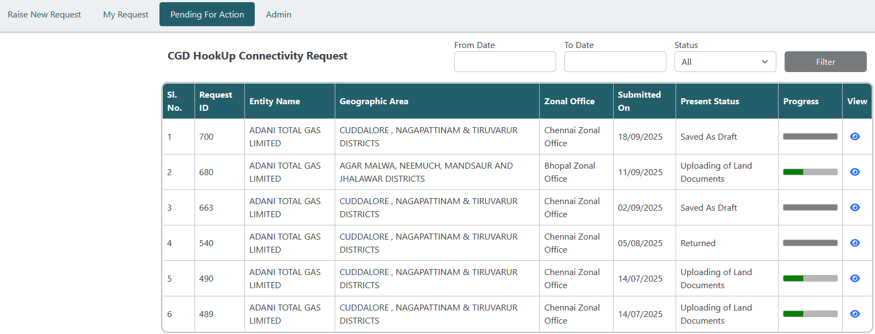

3.6 Admin (GA-User Mappings)
Users can view existing GA-User mappings assigned to them.
