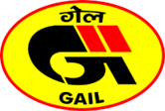
CGD Hooking Up Portal
(User Registration)
[User Manual]

Contents
1 Introduction 2
2 Admin Side 2
2.1 Dashboard 2
2.2 User Authorisation Management 2
2.3 GA-ZO Mapping 3
2.4 Registration 3
2.5 Reports 4
3 User Side 5
3.1 User Registration 5
3.2 User Navigation Points 5
3.3 Raise New Request 6
3.4 My Request 6
3.5 Pending for Action 6
3.6 Admin (GA-User Mappings) 7

Introduction

SAMANVAY is a digital platform developed by GAIL to manage and streamline the process of CGD (City Gas Distribution) connectivity requests, GA-ZO mappings, user authorization, and related approvals.
The system has two interfaces:
- Admin Side: For administrators to manage requests, mappings, registrations, and reports.
- User Side: For CGD entities to register, raise requests, and track progress.

User Side

2.1 User Registration
Entities must register before using the system.
Registration Form Fields:
- Entity Details

  - Entity Name *
  - Corporate Identification No (CIN)
  - PAN *
  - GSTIN Number *
  - Address Line 1 *
  - Address Line 2
  - State * (dropdown)
  - City *
  - PIN *

- Geographic Area Details

  - Geographic Area * (dropdown)
  - GA ID (auto-populated)
  - Zonal Office (auto-populated)

- Contact Details

  - User Name *
  - Designation *
  - Mobile Number * (verify via OTP)
  - Email * (verify via OTP)

Declaration:
The entity must declare PNGRB authorization of at least one GA and confirm information accuracy.
On Submission:
- A unique Entity ID and Password are generated.
- These credentials are used for login.
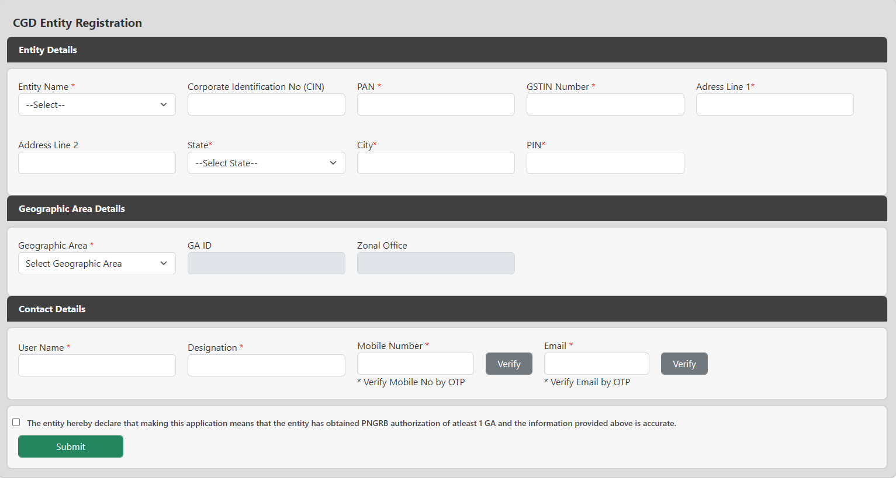

Login with User Id and Password:
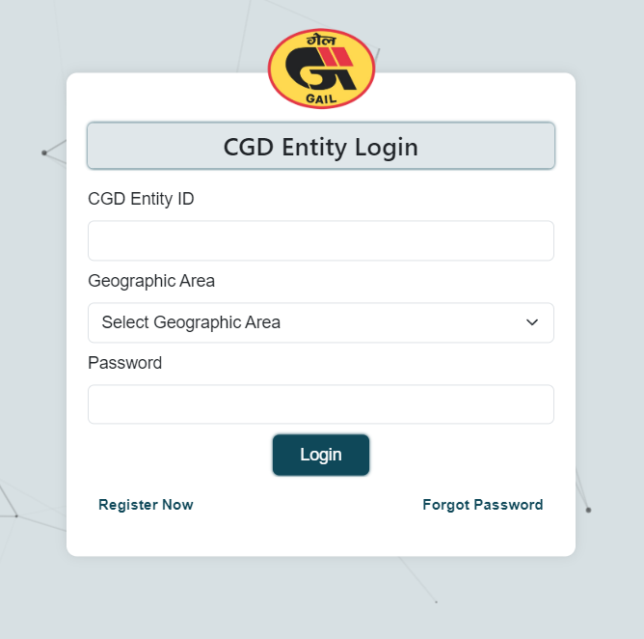

2.3 User Navigation Points

After login, the user can access the following modules:
- Raise New Request
- My Request
- Pending for Action
- Admin (GA-User Mappings)

